Architecture Planning Team (APT)

Tuesday, June 14th, 11:00 AM – 12:00 PM (Eastern Time Zone)

Bridge – 888-412-7808 PIN 23272#

Agenda

- Introductions/Agenda Review – All

- Status of Vendor and Service Provider Test Case Lists – Neustar & Telcordia

Action Item 051011-16: Neustar and Telcordia will create a list of Vendor (ITP) and Service Provider regression test cases, identify which are Vendor (ITP) and which are regression or which are both, determine which are conditional, and which apply to the following four categories:
- New Service Provider and New Vendor,
- New Service Provider and Experienced Vendor,
- Experienced Service Provider and New Vendor,
- Experienced Service Provider and Experienced Vendor.
The status of this work effort will be provided on the June 14, 2011 APT conference call and at the APT portion of the July 2011 LNPA WG meeting.

- Review of New PIM on Pending SVs Preventing Creation of Pooled 1K Blocks – Neustar

(DOCUMENT TO BE DISTRIBUTED SEPARATELY)

Action Item 051011-03: Regarding the requirement in the NPAC preventing creation of a pending pooled 1K block if there is a pending SV within that 1K block, and vice versa, until the pending SV or block is either activated or canceled, .Neustar will write up a PIM problem statement on this issue to be reviewed on the June 14, 2011 APT conference call.

LNPA Working Group

Tuesday, June 14th, 12:00 PM – 2:00 PM (Eastern Time Zone)

Bridge – 888-412-7808 PIN 23272#

Agenda

- Introductions/Agenda Review – All

- Review of Revised Best Practice 25 – Deb Tucker, Verizon Wireless

Action Item 051011-11: Regarding the revision to Best Practice 25 related to the porting of numbers associated with in-vehicle services, Deb Tucker, Verizon Wireless, will add a statement advising that this Best Practice does not apply to non-portable numbers used for these purposes, such as 5YY NXX numbers.

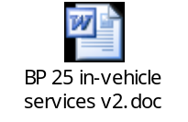

- Review of Revised Best Practice 33 – Deb Tucker, Verizon Wireless

Action Item 051011-15: Service Providers are to review the attached proposed revision to Best Practice 33, which has been modified to include Service Address Number (SANO) per the discussion at the May 2011 LNPA WG meeting, and come prepared to discuss on the June 14, 2011 LNPA WG conference call.

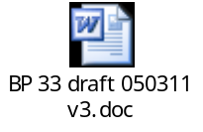

- Review of Revised Best Practice 37 – Jan Doell, CenturyLink
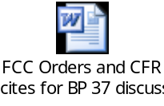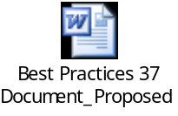

- Review of Proposed “Stolen Number” Best Practice – Sue Tiffany, Sprint Nextel

Action Item 051011-14: Service Providers are to review internally the attached proposed Best Practice on stolen/fraudulently acquired numbers, especially the “safe harbor” statement in the last paragraph, and come prepared on the June 14, 2011 LNPA WG conference call to determine if the Best Practice will be accepted or to suggest any revisions.
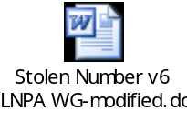

LNPA Working Group

Tuesday, June 14th, 12:00 PM – 2:00 PM (Eastern Time Zone)

Bridge – 888-412-7808 PIN 23272#

Agenda
(CONTINUED)

- Proposed Best Practice on CSRs – Gary Sacra, Verizon

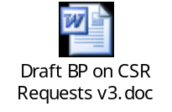

- 2011 LNPA WG Meeting/Call Schedule – All

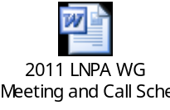

- New Business – All

